**CONTENTS**

TRAINING 5 2

A – 05. GOLD MINING 2

B – NETWORKS 2

C – GOLD MINING (HARD) 2

E – 05. MACHINE 3

F – 05. NURSE 3

G – 05. MARBLE 4

I – 05. TOWER 4

J – 05. WAREHOUSE 5

K – 05. RETAIL OUTLETS 5

L – 05. DRONE PICKUP 5

P – INCREASE SUBSEQ 5

Q – LONGEST COMMON SUBSEQUENCE 6

R – MAX SUBSEQUENCE 6

S – RMQ 6

KẾT QUẢ TRAINING 5 7

# 

# **TRAINING 5**

## **A – 05. GOLD MINING**

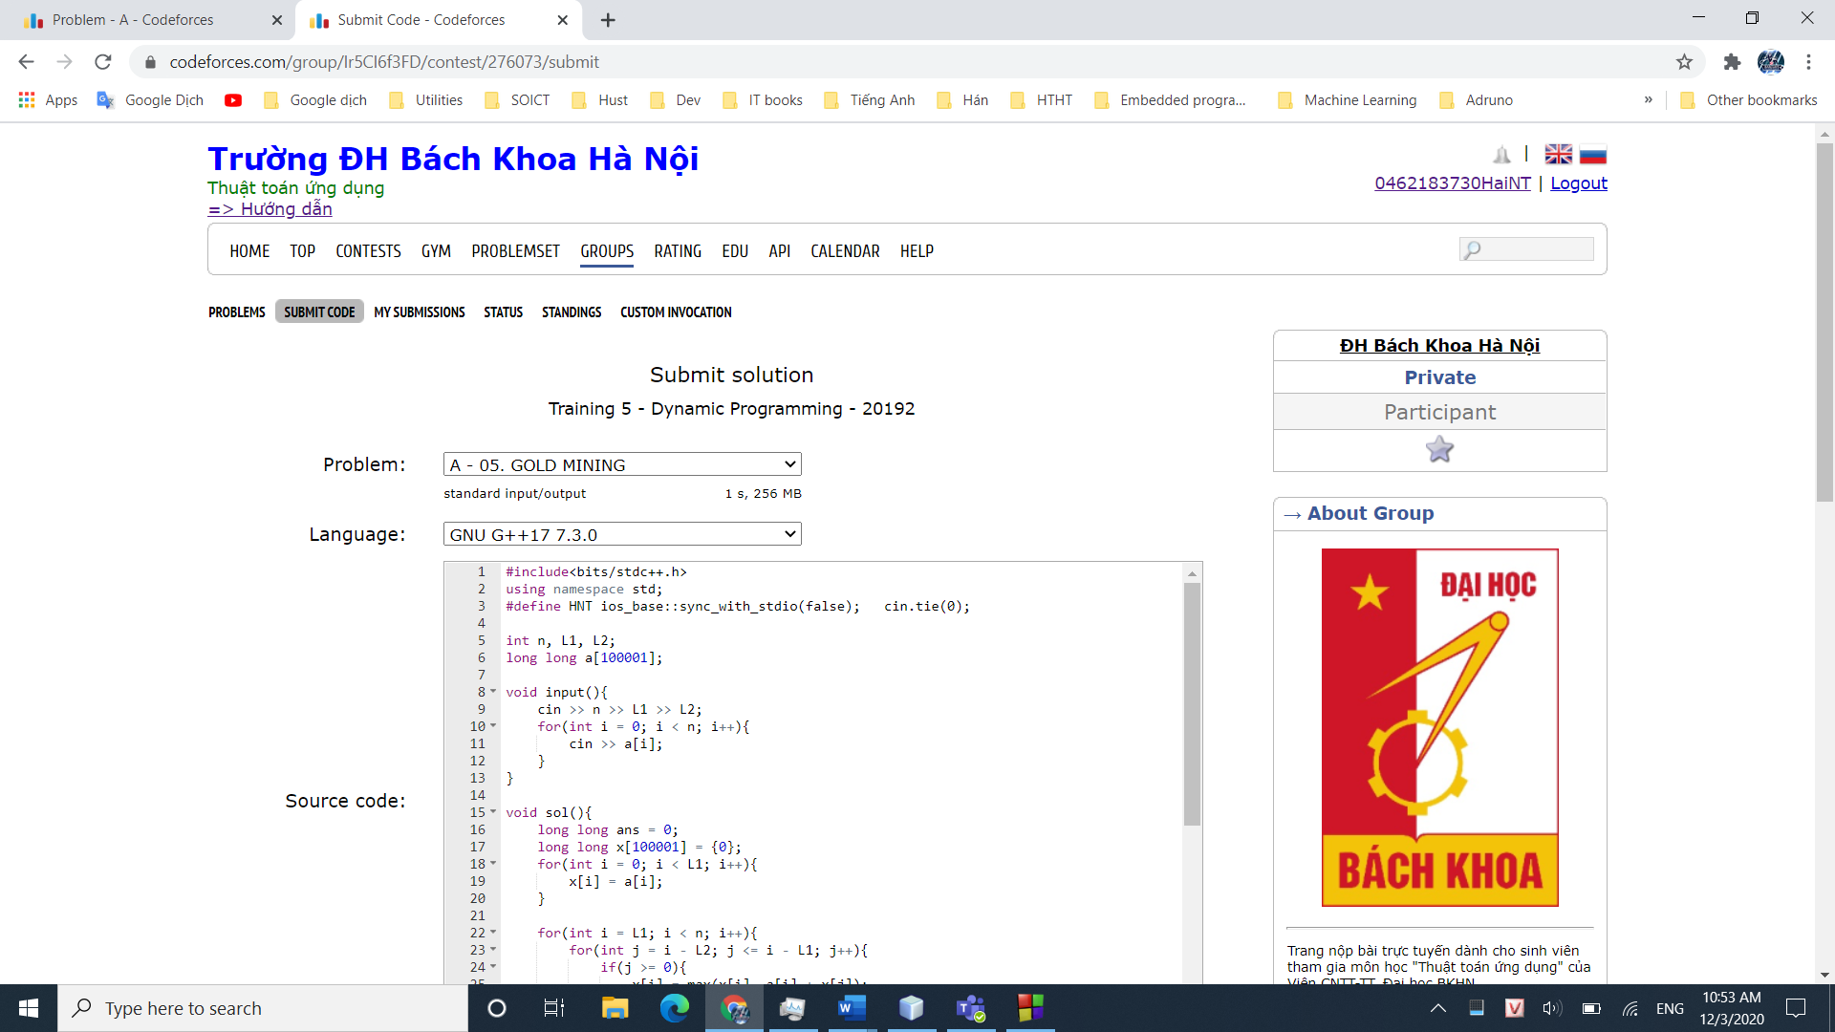

## **B – NETWORKS**

## **C – GOLD MINING (HARD)**

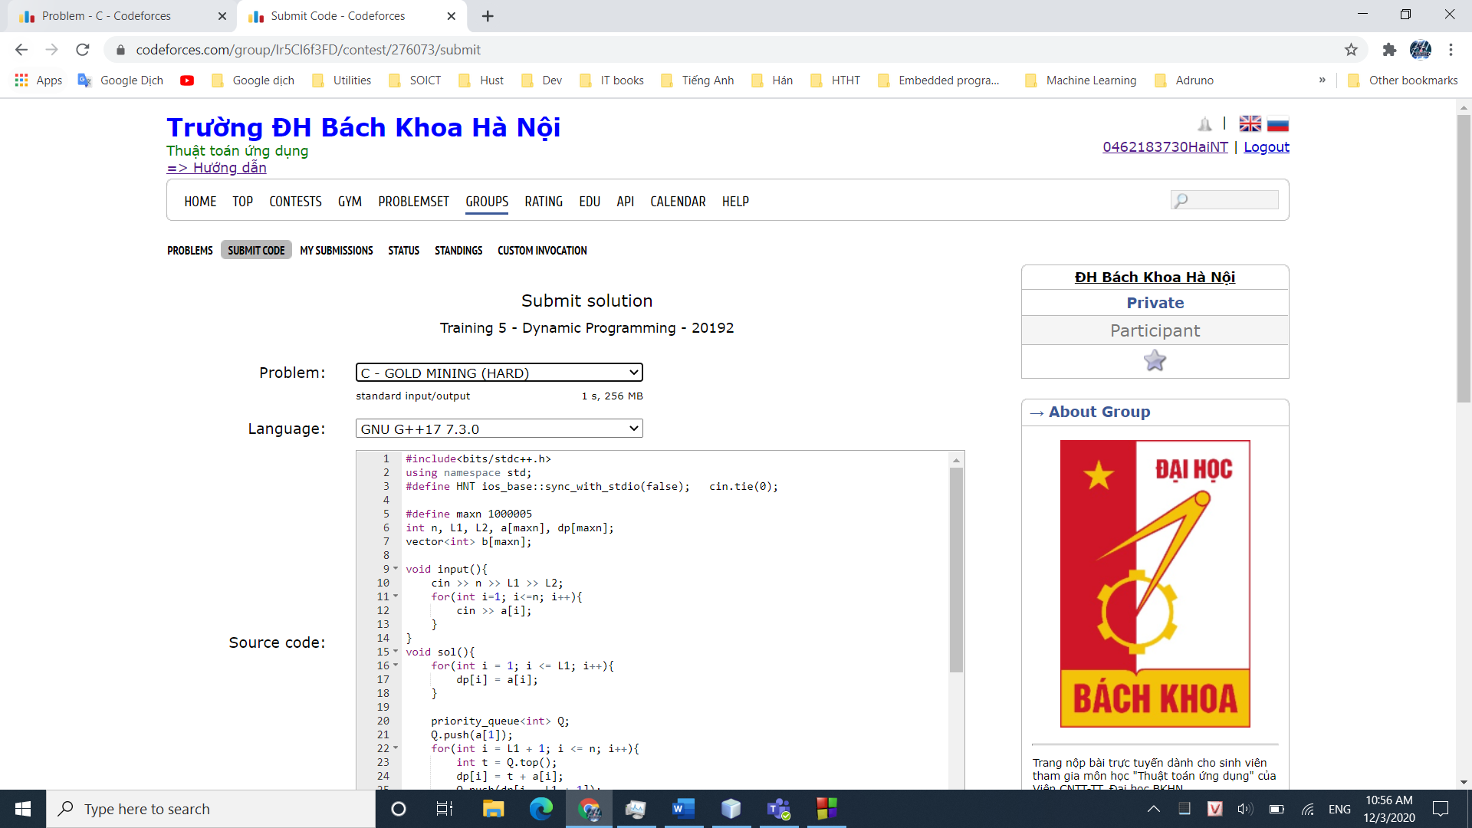

## **E – 05. MACHINE**

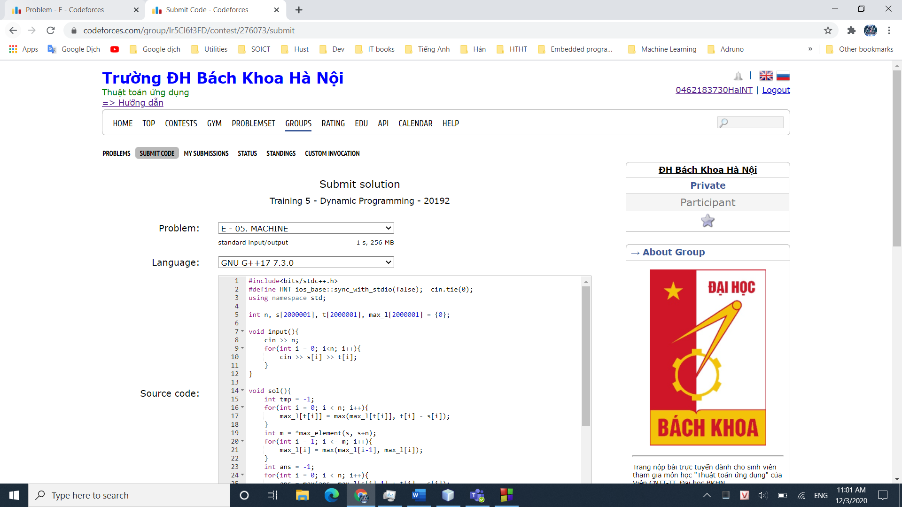

## **F – 05. NURSE**

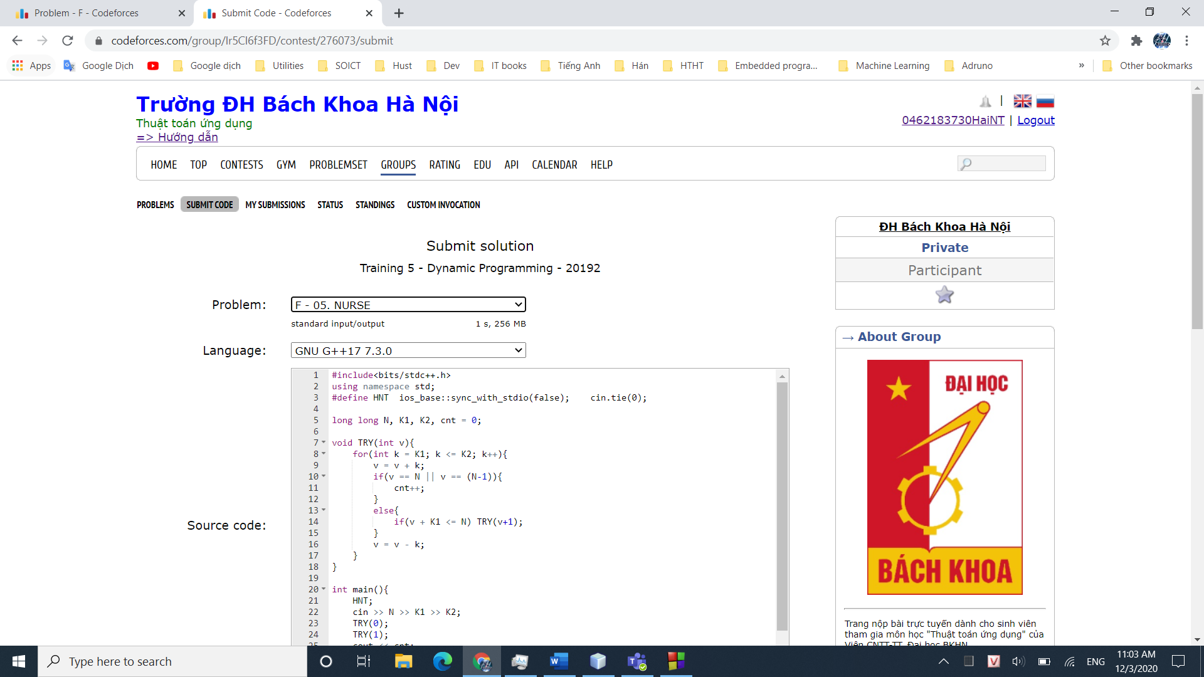

## **G – 05. MARBLE**

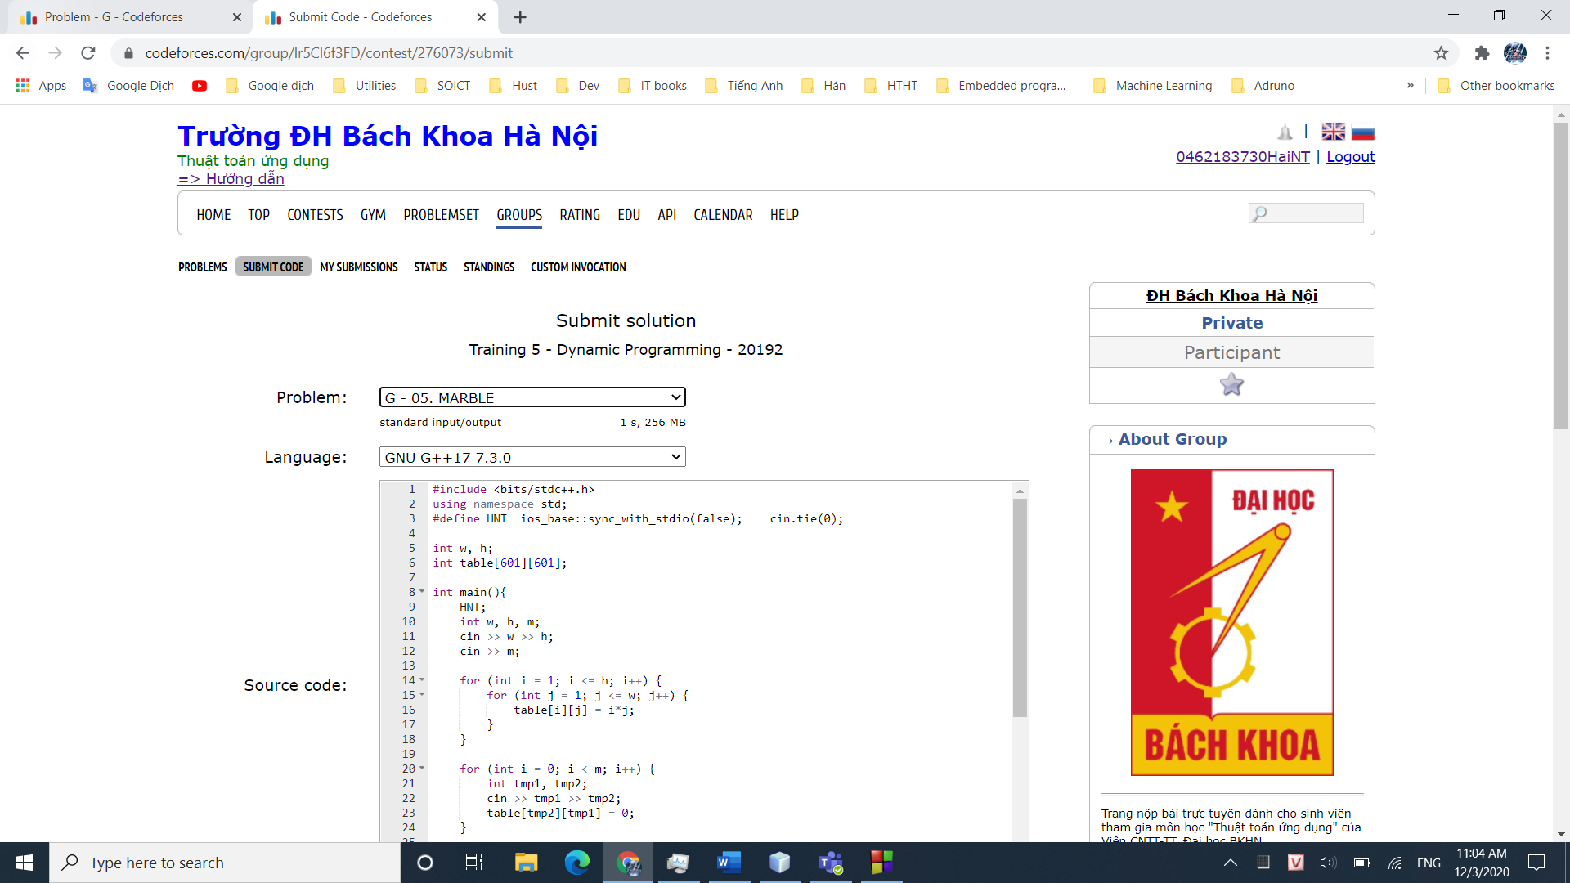

## **I – 05. TOWER**

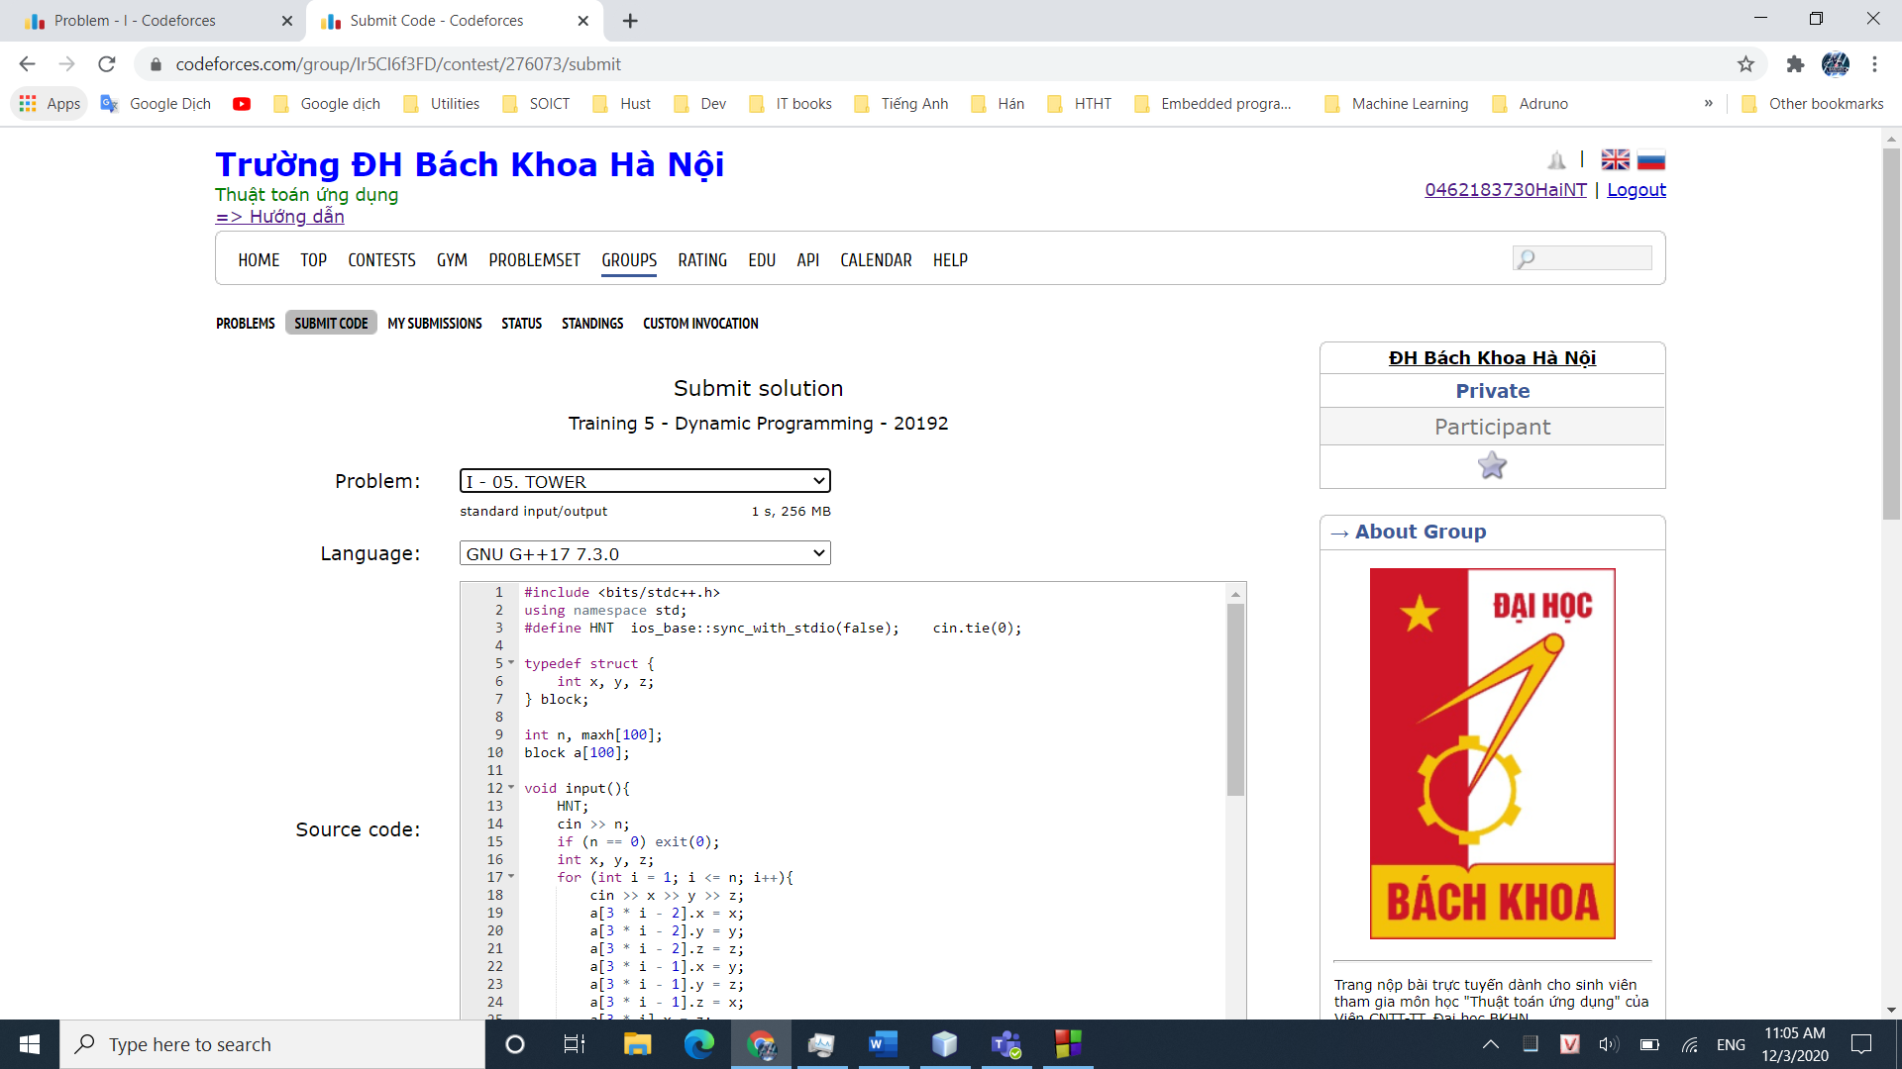

## **J – 05. WAREHOUSE**

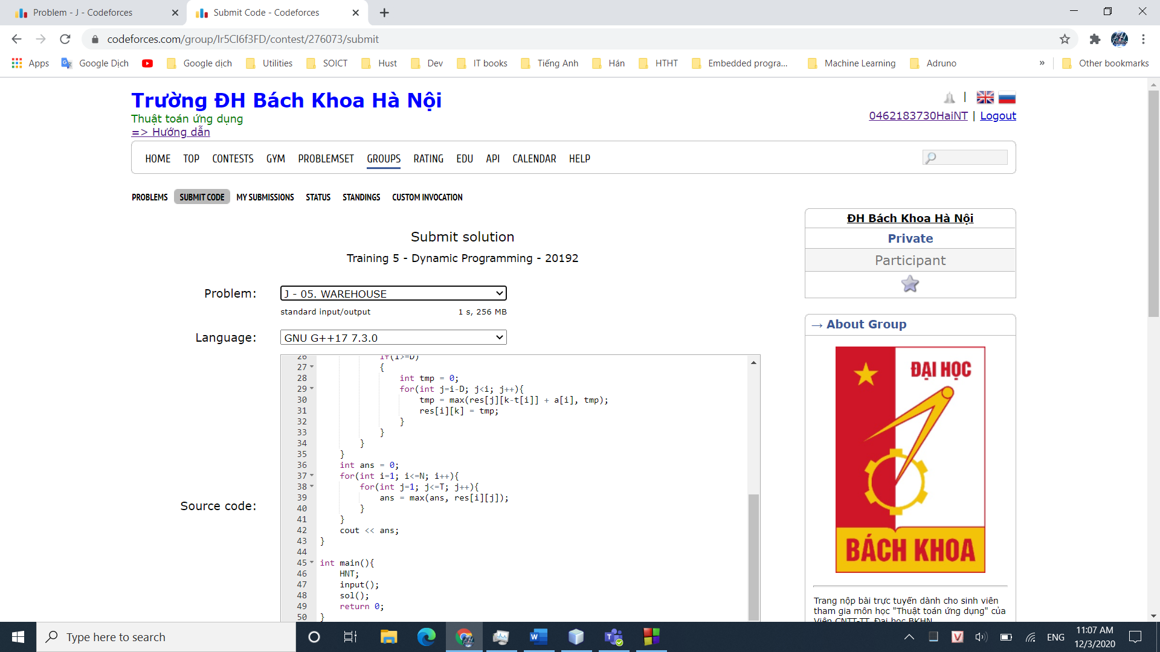

## **K – 05. RETAIL OUTLETS**

## **L – 05. DRONE PICKUP**

## **P – INCREASE SUBSEQ**

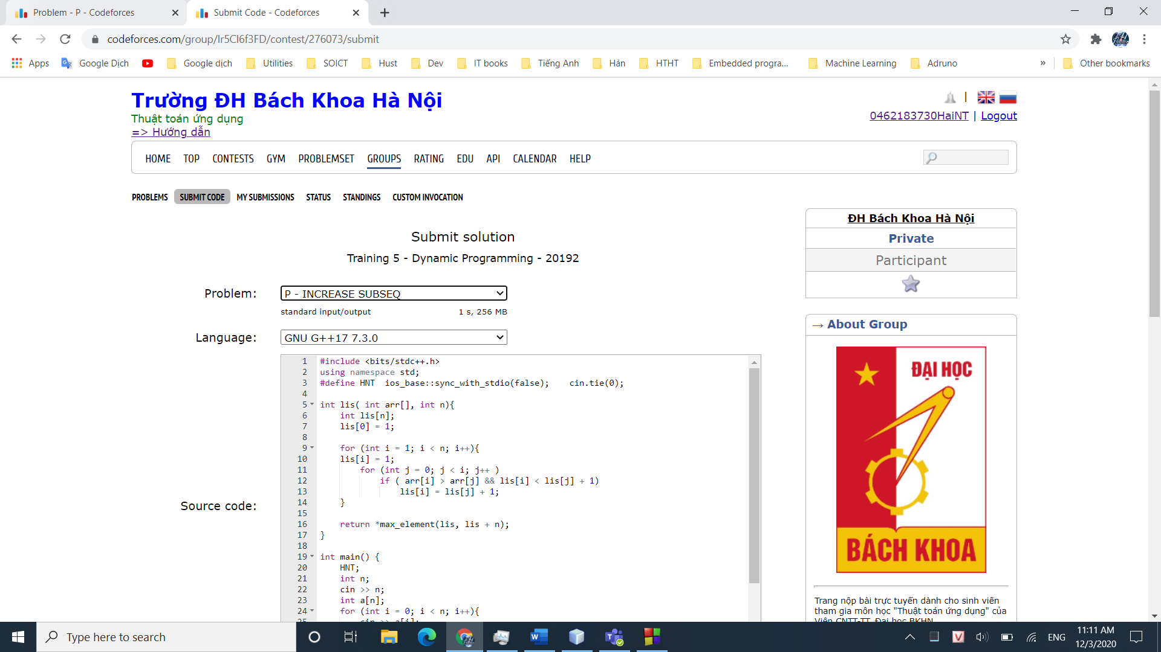

## **Q – LONGEST COMMON SUBSEQUENCE**

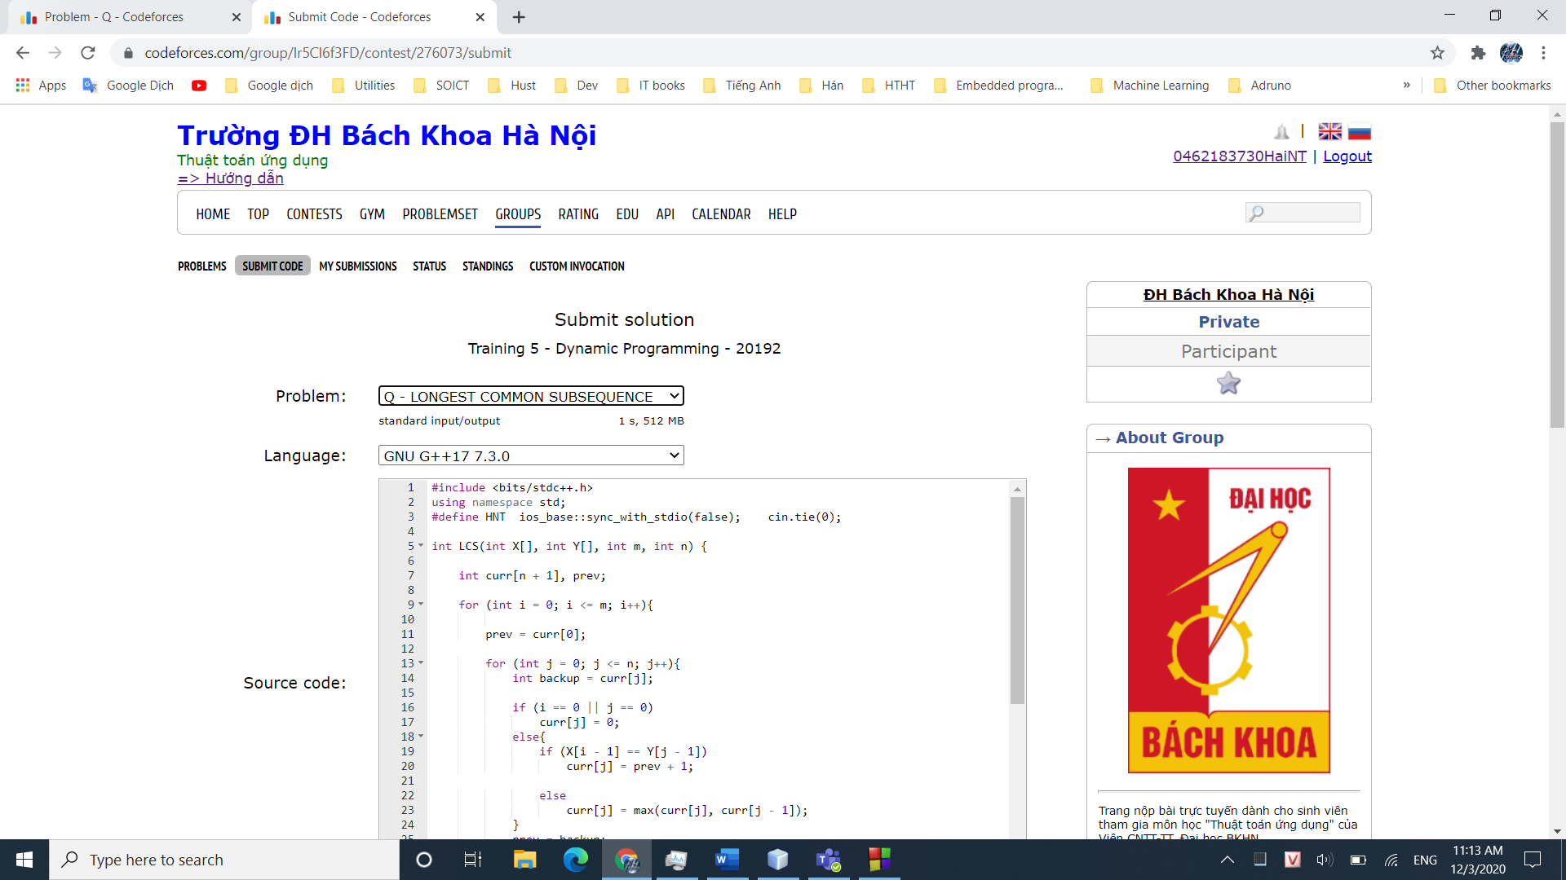

## **R – MAX SUBSEQUENCE**

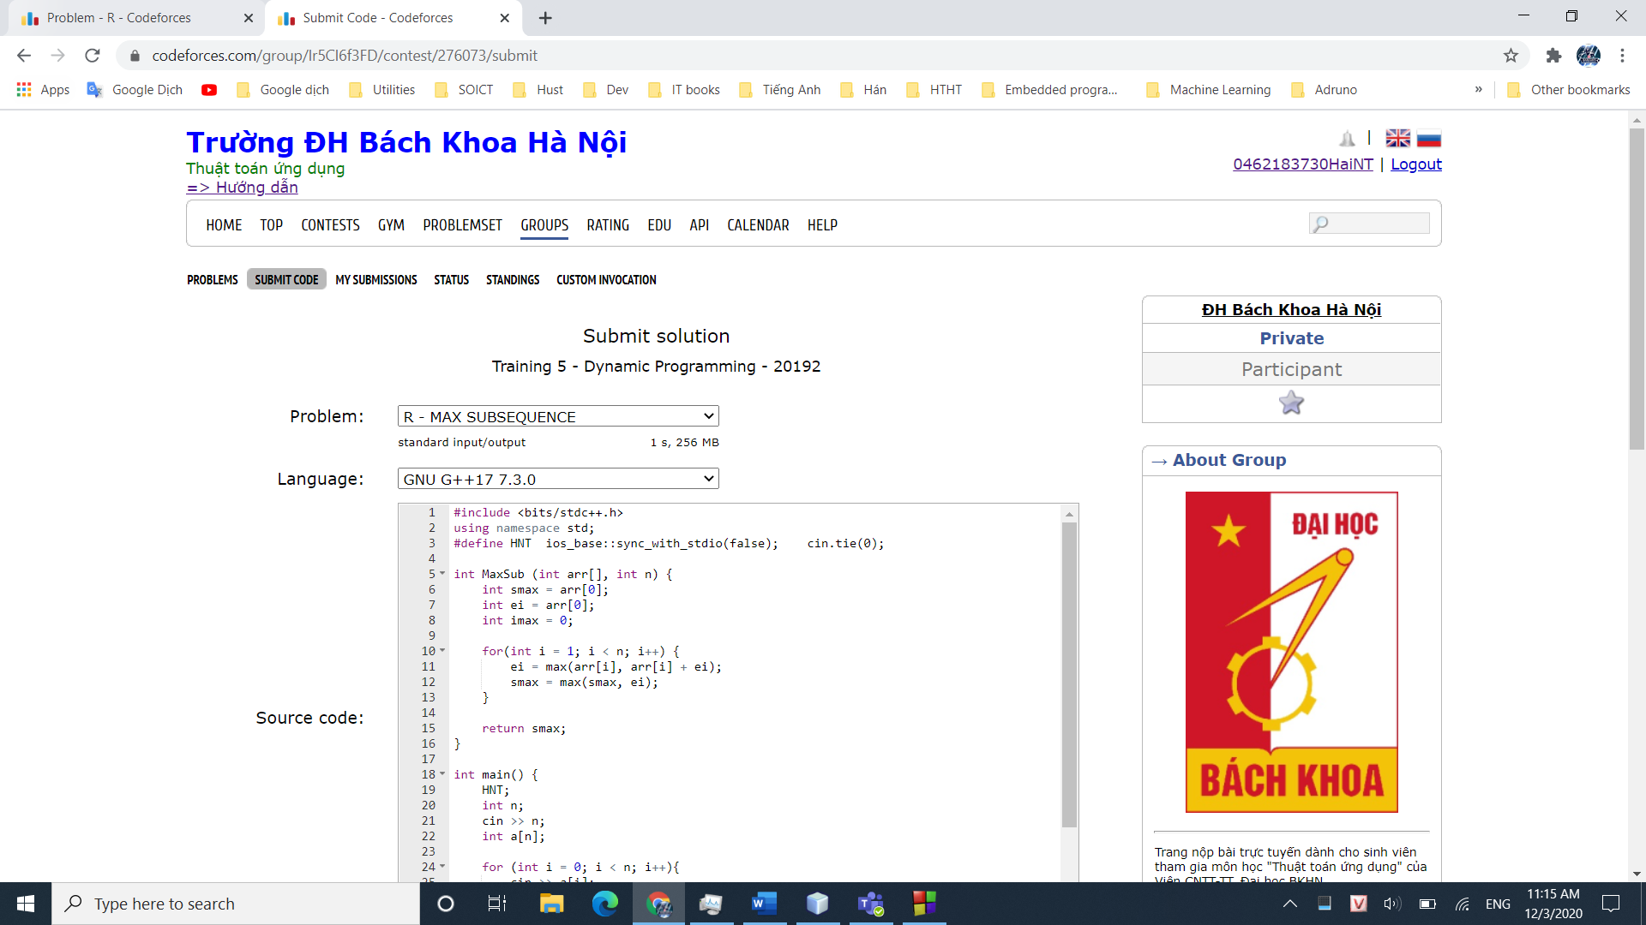

## **S – RMQ**

## 

## **KẾT QUẢ TRAINING 5**

